ADMINISTRATIVE STAFF

President/Founder: Dr. Joe L. Jackson
Dean: Dr. Blanche Wesley
Assistant Dean/Administrative Assistant: Dr. Gloria Ray

INSTRUCTORS

Dr. Joe L. Jackson
Dr. Blanche Wesley
Dr. Donald Washington
Dr. Lorenzo Wesley, Sr.
Timothy Bradford, Th.M.
Dr. Ceasar Felton
Dr. Gloria Ray
Dr. Walter Williams
Dr. Noel A. Watson, Jr.

BOARD OF DIRECTORS

President: Marvin Williams
Secretary: Joyce McNair
Rev. Alphonso Clark
Brenda Parks
Earnestine Epps
Adam Jackson

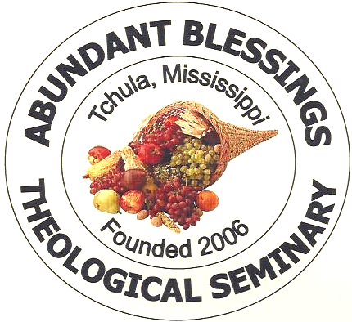

I am come that they might have life, and that they might have it more abundantly.
~ Jn. 10:10 (KJV)

Contact Information:
Dr. Gloria Ray
Administrative Assistant/Assistant Dean
(662) 247-2886

ABUNDANT BLESSINGS SEMINARY
P O BOX 134
TCHULA, MS 39169
PHONE: (662) 247-2886

10829 Highway 49E North, Tchula, MS

Abundant Blessings
Theological Seminary

THE DELTA’S GATEWAY



To Developing

Intellectual

&

Spiritual

Leadership

Skills

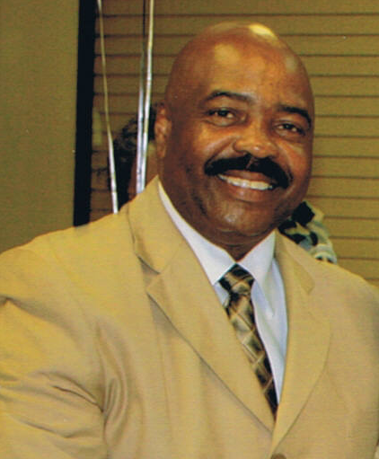

FROM THE PRESIDENT

Abundant Blessings Theological Seminary provides a spirit-filled Christ-centered atmosphere. Its faculty and staff are dedicated to high academic standards and group world view that celebrates the deity of the Lord Jesus Christ. We are dedicated in helping to develop intellect and spiritual leadership skills; equipping the saints to go out into the hedges and highways to compel men and women to come to God so that they may have life more abundantly!
Since the Bible is the infallible Word of God; we believe it is the basis for the total curriculum. Students are equipped with the necessary skills to understand and teach the scriptures, developing above all, a burning desire to know and to do the will of God as revealed in the Old and New Testaments.
It is my sincere desire that everyone who attends Abundant Blessings Theological Seminary will be endowed with a fuller understanding of God, thereby receiving the abundance of God’s promises through our Saviour Jesus Christ.

Dr. Joe L. Jackson, President
HISTORY

By the guidance of the Holy Spirit; Abundant Blessings Theological Seminary was founded and established by Dr. Joe L. Jackson in August, 2006.

Abundant Blessings Theological Seminary is a fully National and International Accredited Seminary.

Abundant Blessings Theological Seminary is free from denominational control. The seminary recognizes that there are various denominations and Christian organizations that hold views concerning doctrine, missions, and evangelism different from its own distinctive beliefs. While committed to fulfilling its purpose and adhering to its doctrines and distinctives in these areas, the seminary resolves to maintain openness to, and appreciation for Christians in differing denominations and organizations, with loving and endearing spirit, thus contributing to the purity and unity of the Christian community and witness.

MISSION

Developing persons for Christian Ministry through demonstrating and instructing intellectual and spiritual leadership skills
CURRICULUM/DEGREES
Associates, Bachelor's,
Master's, and Doctorate
Degrees in Divinity and Theology
Certificate of Christian Education

Tuition
Abundant Blessings Theological Seminary
offers quality education at an affordable cost.

Registration Fee . . . . . . $25.00

Associates Program . . . . $400.00 per semester

Bachelor's Program . . . . $400.00 per semester

Master's Program . . . . . . $500.00 per semester

Doctorate Program . . . . $600.00 per semester

Accelerated Program . . . $200.00

Bible Basic Review Exam . . . $100.00
(required for all Bachelor students)

Graduation fees vary
Prices are subject to change
Textbooks are student’s responsibility

Registration:

Transcripts are required for registration. High school, college, seminary and Bible college certificate or Seminary certificate.
Classification will be determined on the basis of Christian experience resumé, and transcript.

